WHY BIRTH PHOTOGRAPHY?
August 24, 2017 In Birth Stories

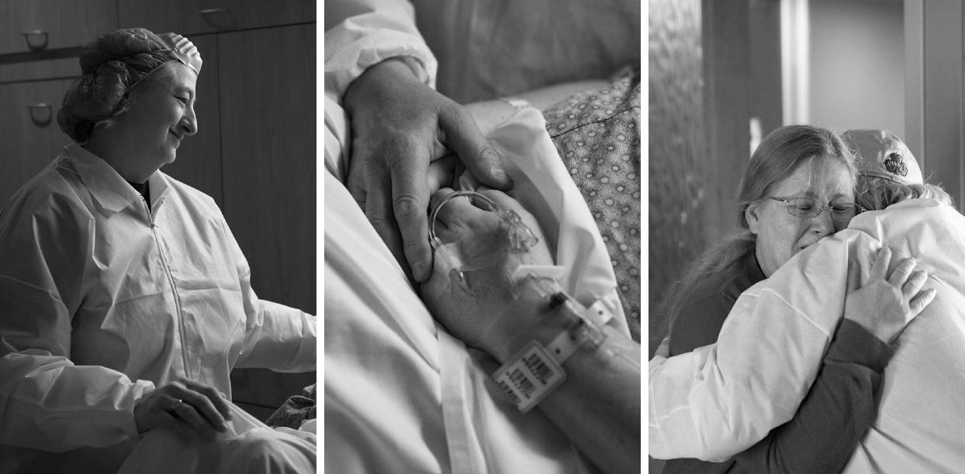

“Geeze Louise, is everything under photographic scrutiny these days? Can’t my naughty bits at least get a pass?” – Me before kids

Birth Photography (aka Labor and Delivery Photography or Birth Story Photography) is a fairly recent genre of photography. It’s also one that is met with great incredulity…and hands down my favorite type of session. For many expecting parents the last few years have involved engagement photos, wedding photos, and maternity/adoption photos. There may have been a proposal, bridal, trash-the-dress, boudoir, or gender reveal session lumped on there too. If this describes you, it’s understandable that you’re starting to feel like a celebrity with paparazzi following you. You’re exhausted buying coordinating ensembles. I get it.

Admittedly some sessions are not “necessary” and the cost not always justified. However, there are two times in life that people always regret not having better photos: their wedding day and the birth of their children. Not coincidentally, these are two life-changing events that cannot possibly be recreated later. They involve family members who may never appear in our photos again. They are days of incredible joy and unbelievable humanity. So why is birth photography considered a luxury or even inappropriate? Having experienced birth twice myself and now talking to other moms who have chosen to document their birth stories, I understand how incredibly lucky we are to live in the age of heightened exposure.

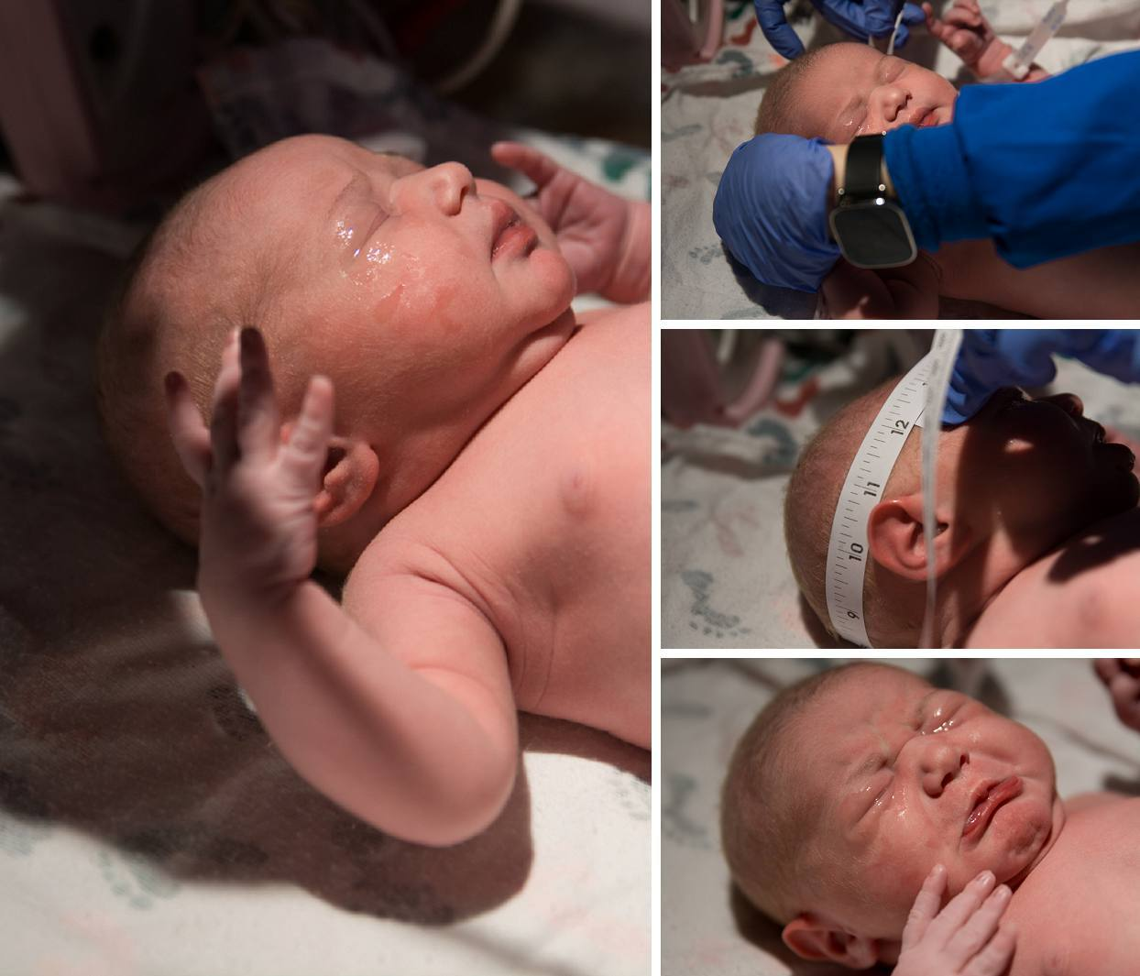

Here are just a few reasons why you should consider birth photography:

- Warm but seriously fuzzy memories – Exhaustion, pain, hormones, medications, trauma, and anesthesia. At least some of these affect every birthing mother’s focus and memory. For one of my clients it was all of the above. She remembered virtually nothing about her traumatic first birth experience. Being completely put under during her Caesarian effectively wiped out her memories from earlier in the day as well. Her recollection of her son’s birth was what people had told her or blurry cell phone pictures. She was determined to properly photograph her second birth in case it happened again. Photographs can help anyone keep their memories of events clear and special. “I completely forgot the nurse with the unibrow!” – You 10 years later
- Limited visibility – During labor I was unable to appreciate what was happening. All I saw below me was belly. I couldn’t see my mom and my husband’s reactions beside me. I certainly couldn’t see myself experiencing that life-altering day. Man I would have loved to have someone capture those emotions! That’s why you need a third party. Mom gets a replay of events and everyone else gets to be in the moment – not the viewfinder of a camera.

- Where are you taking my baby? – As frustrated as I felt with my vantage during birth, things got really disappointing afterwards. Even the most straight-forward births mean downtime for mom while baby’s first moments transpire AWAY FROM YOU. This gets worse if there are complications, prematurity, or surgery. You get the kid for a few seconds of skin-to-skin and then it’s like, “Enjoy delivering that afterbirth sweetie. Your kid will return when he’s 12.” There are vitals to be taken, documents prepared, and white gunk to be wiped off of them. I saw exactly none of this. I’m so jealous of my husband and the nurses who experienced this moment while I stared at their backs. “I guess I’ll have to experience it through pictures!” I conceded. Only for my son we left the camera at home on accident. Yeah. Nada.
- Greetings from afar – Is somebody special going to miss the birth? Maybe it’s grandma a few states over, a deployed partner in the military, or the future adoptive parents whose heart wishes they could be there. Heck, maybe it’s just your sister in the waiting room. Documenting birth is a way of bringing everyone in on a day where the audience is limited.
- For our posterity – How cool would it be to look back on pictures of your birth – a time that you can’t possibly remember but was absolutely vital to your presence here today? How young would your mom have looked? How would you feel seeing her reaction to your squishy face for the very first time? How warmly would you feel toward the family that doted upon her? How much more would you appreciate the characters who ensured you lived to see the day? Imagine giving that to you kids! Now imagine artistic images that are worthy of framing too!
- The good, the bad, and the ugly – You can choose to be as modest as you wish during your birth photos. Nobody need see the gory details if you wish. But even the images of your face, your partner, and the nuanced details of your personal experience are a beautiful and unique story. Seeing these stories helps other mothers understand this magical (albeit a little gross) process. We see dramatic screaming on TV and rarely the rewarding moments strewn throughout the whole experience. Birth photos of any kind show everyone who sees them that there is nothing else as amazing and transformative as birth. The collection of images answers the questions all new moms get: Did it hurt? Was it worth it? Would you do it again? Yes. Yes! YES!!
- Life and death situation – I hesitate to mention this point because it’s unpleasant and can be seen as me tugging at your heartstrings for income. That’s not my intention. But it bears mentioning because it weighs on my mind as I prepare myself. Although it’s something none of us wish to think about, birth and death are intimately related. Even in the developed world, fetal and maternal mortality are a reality. If the very worst were to happen, the intense love you had for this child will be apparent in your photos. The worthiness of the experience, despite the ending, will be clear. It may be the last memories you have together. Let them resonate with the power they deserve and serve as a catharsis. (Aaand now I’m crying.)
- You go girl! – Sooo…to not leave you on a totally depressing note, remember that pictures of your child’s birth story are also the story of you becoming a mom. Look at you power through those contractions rock star! You survived a huge ordeal! You made an actual human with no instructions…holy crap right? Look at these photos often and tell yourself, “I did that. I made that. I can do anything in this whole world!!”

AND NOW FOR SOME HILARIOUS(LY BAD) PERSONAL EXAMPLES
Wow. Taking your camera out of “Auto” sure does change your life! I wish I could go back…

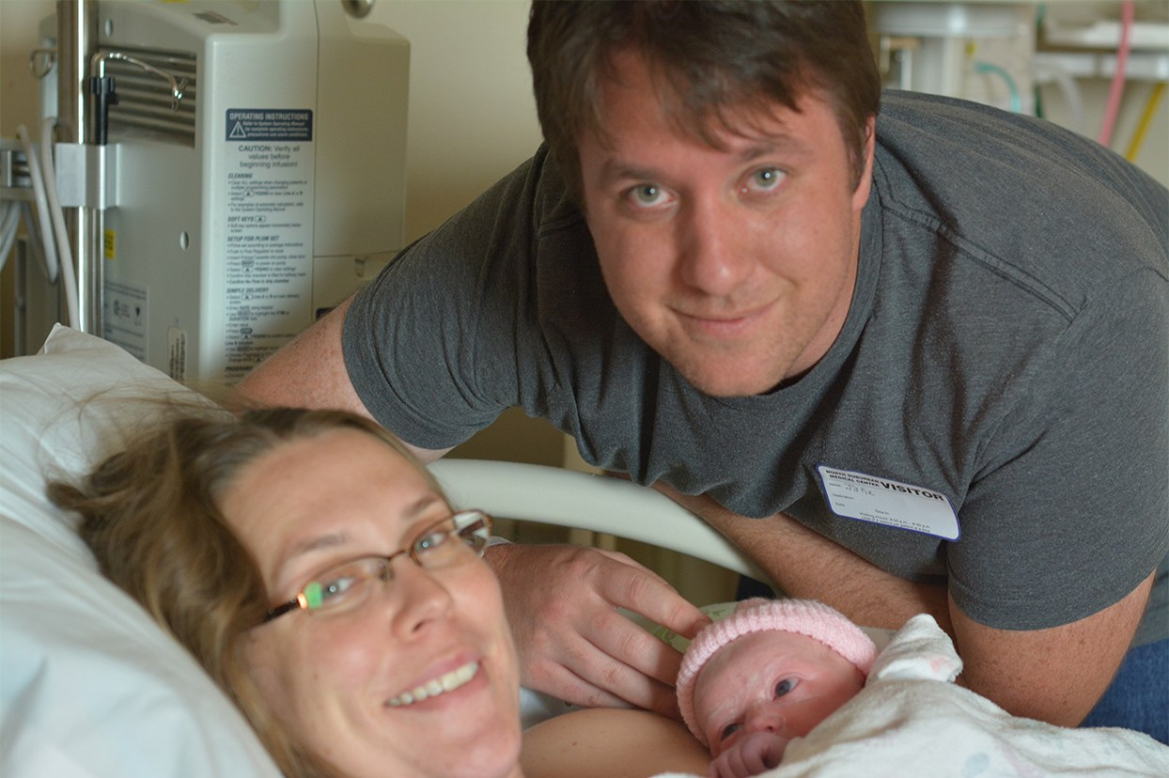
This is what happens when you let relatives take pictures. At least my daughter’s face was kinda in focus…

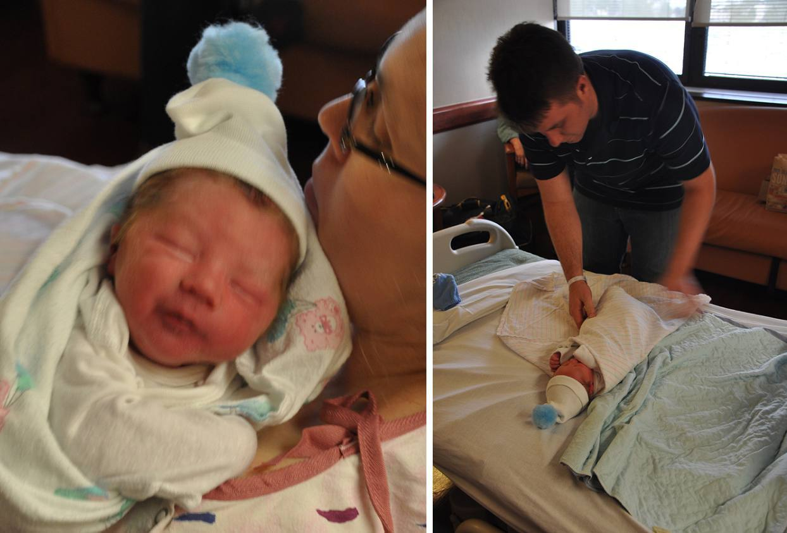

Meet my son Blur. He takes after his dad, The Flash.
(Come to think of it, use of flash would have fixed this issue. I’ve learned so much..)

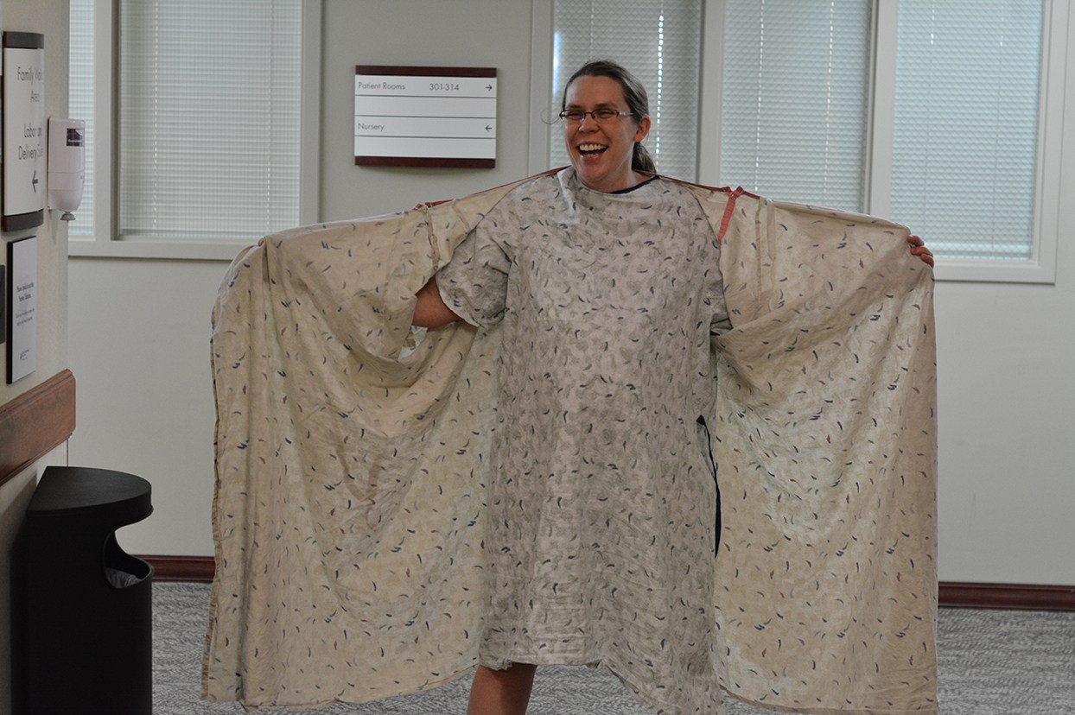

Did somebody say flash?

